**Communications Lab**

**Experiment No. 1**

**Amplitude Modulation (AM) and Demodulation**

**190020039**

**a. Conventional AM technique**

*CODE:*

clear all

fs=100; %sampling freq

t=0:1/fs:10; %declaring time array

m=2*sin(2*pi*t)+cos(2*pi*t); %message signal

fc=10; %carrier freq

amod=0.8; %modulation index

Mo=abs(min(m)); %min t of m(t)

A=1;

Ac=A*Mo/amod;

uam=(A*m+Ac).*cos(2*pi*fc*t); %conventional AM signal

%conventional AM signal in FREQ domain

Uam1=fft(uam); %FT of AM sig (not centered around 0)

Uam=fftshift(Uam1);

n=length(uam);

f1=(-n/2:n/2-1)*fs/n; %freq array for AM signal

%demodulated signal

%envelope func detects the upper peak envelope

%Ac is subtracted to get original signal

dmd=envelope(uam,1,'peak')-Ac;

%demodulated signal in FREQ domain

Dmd1=fft(dmd); %FT of demodulated signal (not centered around 0)

Dmd=fftshift(Dmd1);

n=length(dmd);

f2=(-n/2:n/2-1)*fs/n; %freq array for demodulated signal

%plotting message signal

figure(1);

subplot(2,1,1);

plot(t,m)

title("Message signal m(t)")

xlabel("t")

ylabel("|m(t)|")

%plotting carrier signal

figure(1);

subplot(2,1,2);

plot(t,cos(2*pi*fc*t))

title("Carrier signal")

xlabel("t")

ylabel("Amplitude")

%plotting conventional AM signal in time domain

figure(2);

subplot(2,1,1);

plot(t,uam)

title("Conventional AM signal Uam(t)")

xlabel("t")

ylabel("|Uam(t)|")

%plotting freq domain plot of conventional AM signal

figure(2);

subplot(2,1,2);

plot(f1,abs(Uam))

title("Freq domain plot of conventional AM signal Uam(f)")

xlabel("f")

ylabel("|Uam(f)|")

%plotting Demodulated signal in time domain

figure(3);

subplot(2,1,1);

plot(t,dmd)

title("Demodulated signal dmd(t)")

xlabel("t")

ylabel("Amplitude")

%plotting freq domain plot of demodulated signal

figure(3);

subplot(2,1,2);

plot(f2,abs(Dmd))

title("Freq domain plot of demodulated signal Dmd(f)")

xlabel("f")

ylabel("|Dmd(f)|")

*OUTPUT PLOTS:*

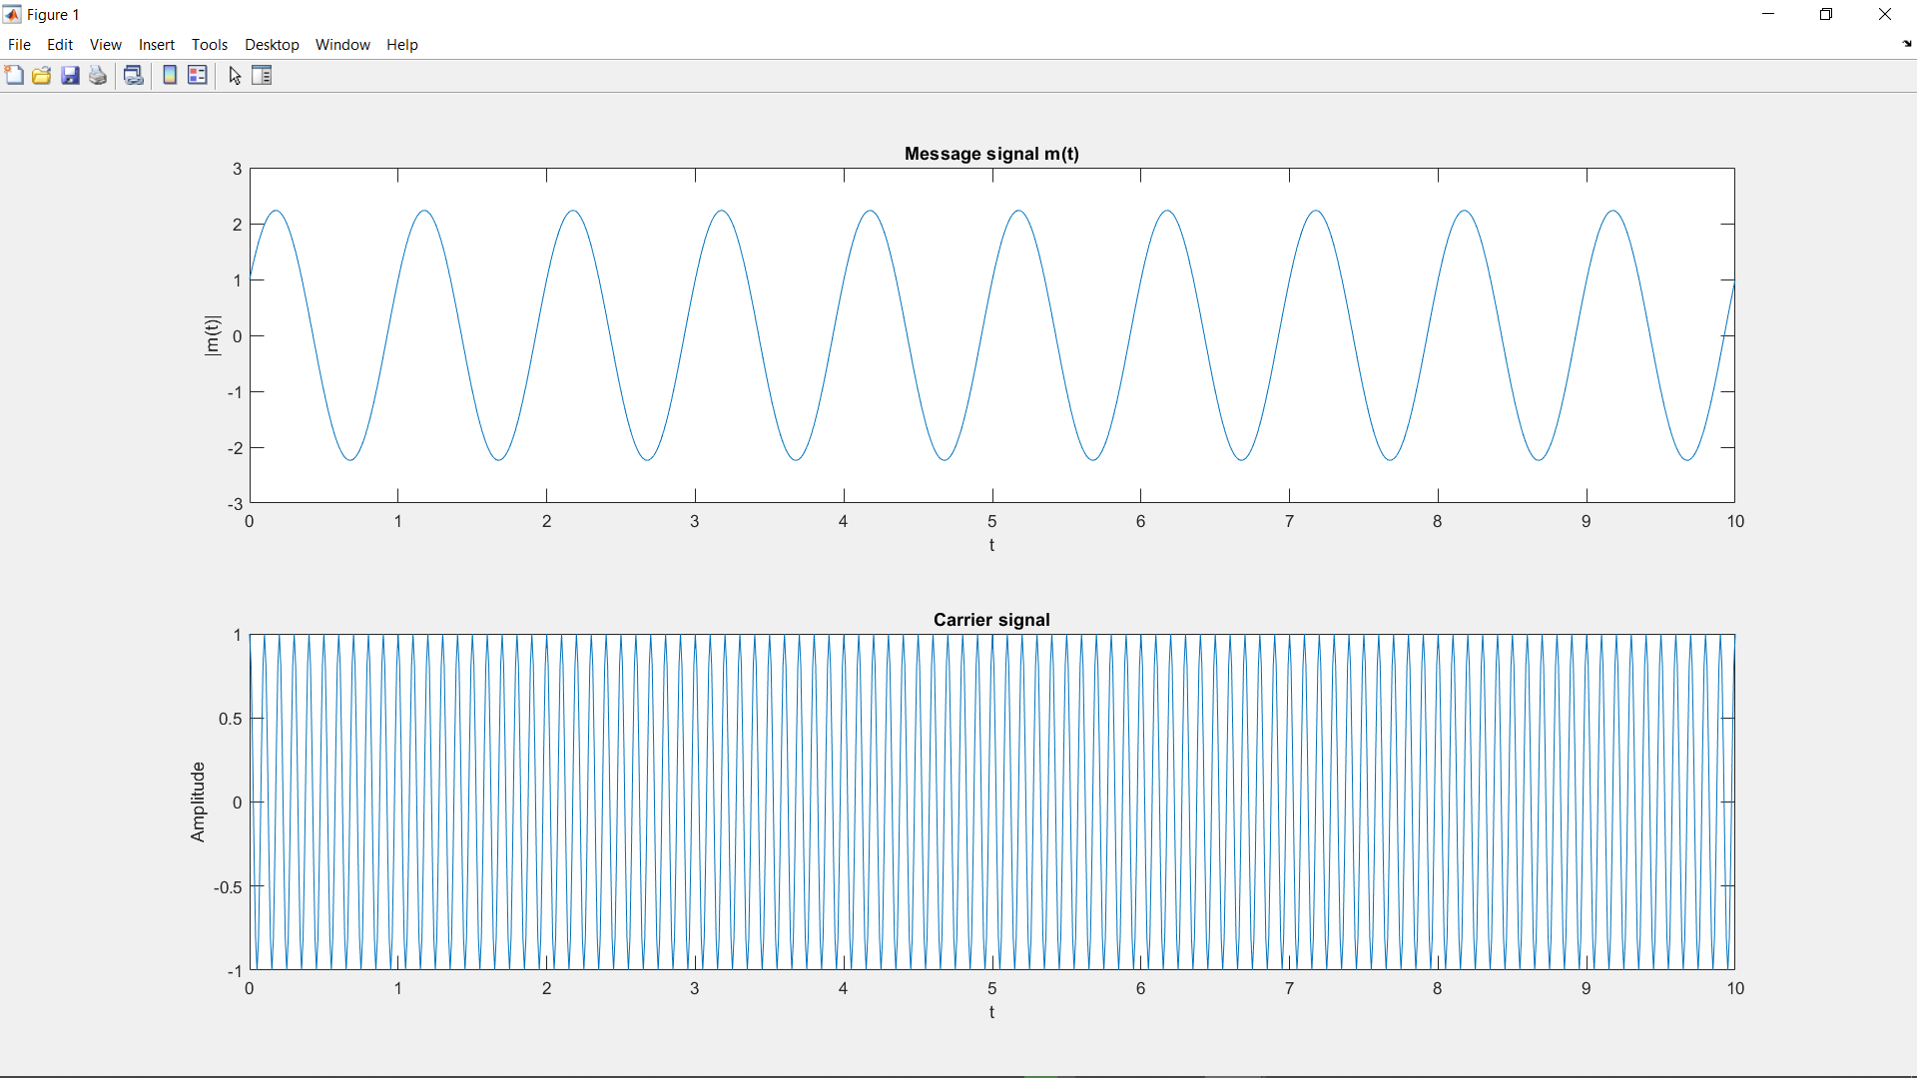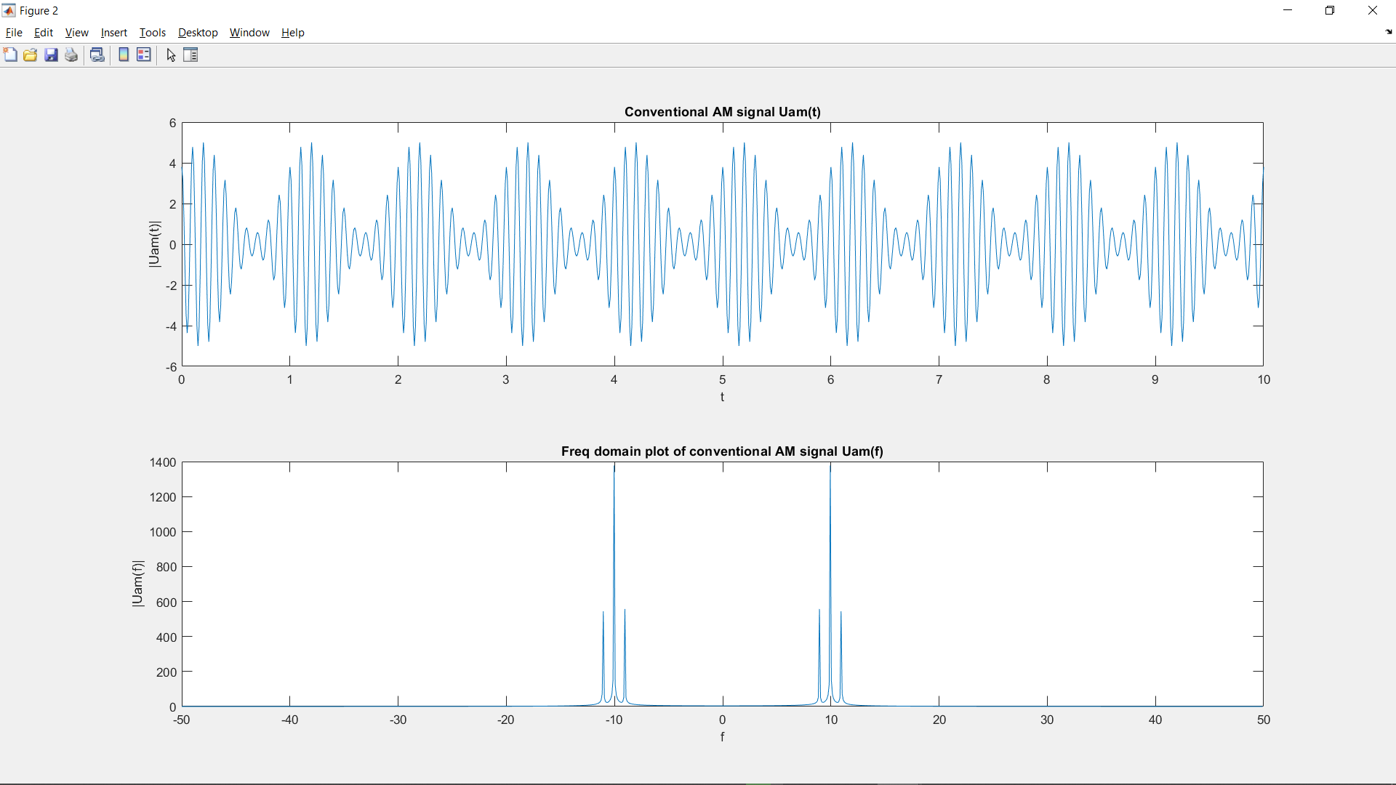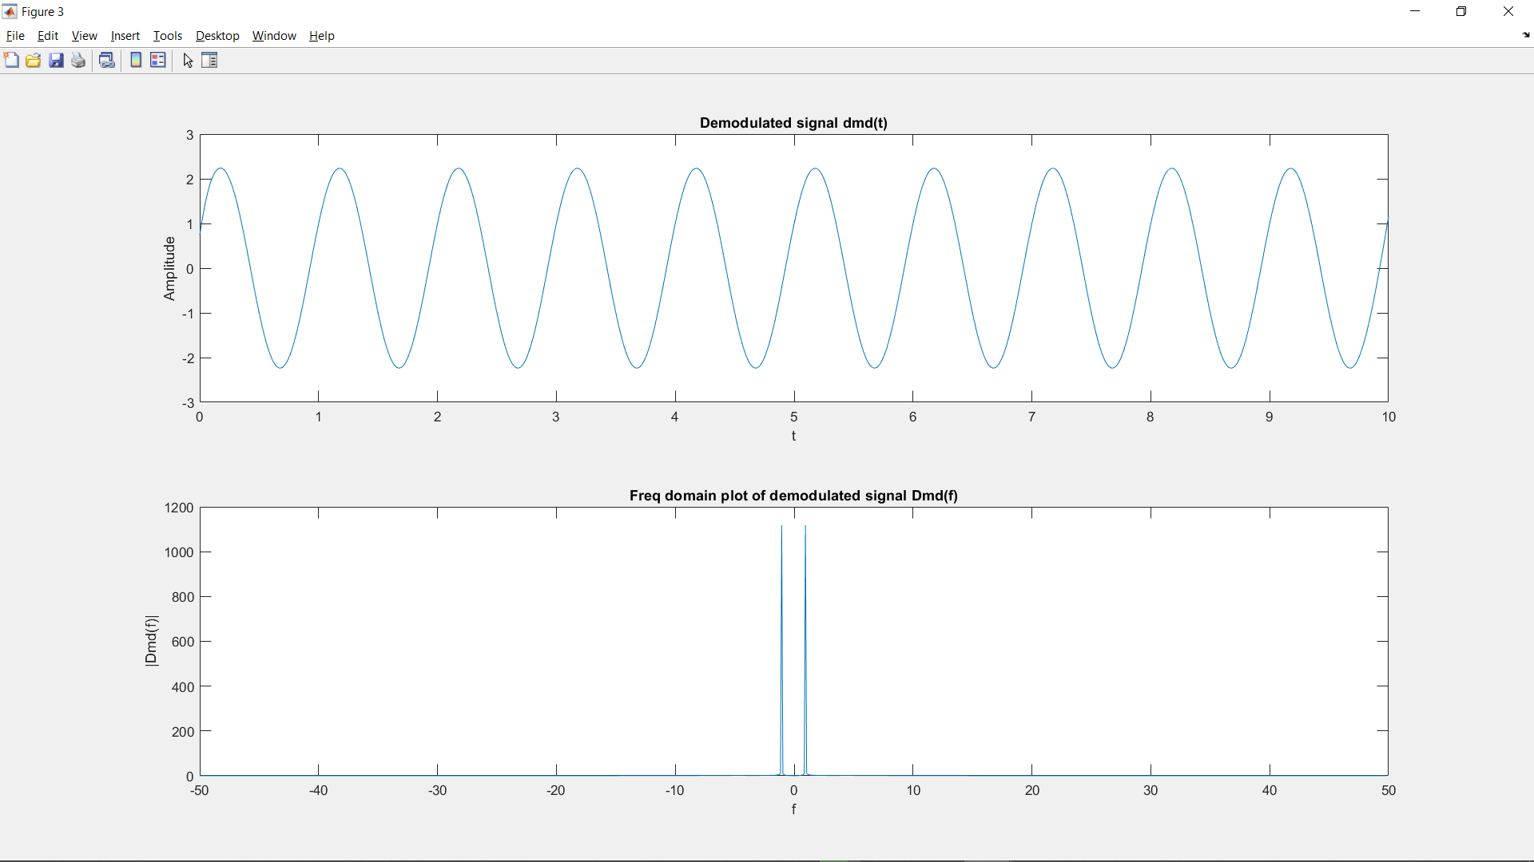

*Inferences/Observations:*

Shape of message signal can be seen in Amplitude envelope of AM signal.

The demodulated signal is same as the message signal.

——————————————————————————————————————————

**b. Double Sideband Suppressed Carrier (DSB SC) modulation technique**

*CODE:*

clear all

fs=100; %sampling freq

t=-10:1/fs:10; %declaring time array

m=2*sin(2*pi*t)+cos(2*pi*t); %message signal

fc=10; %carrier freq

A=1;

udsb=A*m.*cos(2*pi*fc*t); %DSB SC signal

%DSB SC signal in FREQ domain

Udsb1=fft(udsb); %FT of DSB SC sig (not centered around 0)

Udsb=fftshift(Udsb1);

n=length(Udsb);

f1=(-n/2:n/2-1)*fs/n; %freq array for DSB SC signal

%demodulated signal

dmd1=2*udsb.*cos(2*pi*fc*t);

dmd=lowpass(dmd1,fc/3,fs);

%demodulated signal in FREQ domain

Dmd1=fft(dmd); %FT of demodulated signal (not centered around 0)

Dmd=fftshift(Dmd1);

n=length(dmd);

f2=(-n/2:n/2-1)*fs/n; %freq array for demodulated signal

%plotting message signal

figure(1);

subplot(2,1,1);

plot(t,m)

title("Message signal m(t)")

xlabel("t")

ylabel("|m(t)|")

%plotting carrier signal

figure(1);

subplot(2,1,2);

plot(t,cos(2*pi*fc*t))

title("Carrier signal")

xlabel("t")

ylabel("Amplitude")

%plotting DSB SC signal

figure(2);

subplot(2,1,1);

plot(t,udsb)

title("Conventional AM signal Udsb(t)")

xlabel("t")

ylabel("|Udsb(t)|")

%plotting freq domain plot of DSB SC signal

figure(2);

subplot(2,1,2);

plot(f1,abs(Udsb))

title("Freq domain plot of DSB SC signal Udsb(f)")

xlabel("f")

ylabel("|Udsb(f)|")

%plotting Demodulated signal in time domain

figure(3);

subplot(2,1,1);

plot(t,dmd)

title("Demodulated signal dmd(t)")

xlabel("t")

ylabel("Amplitude")

%plotting freq domain plot of demodulated signal

figure(3);

subplot(2,1,2);

plot(f2,abs(Dmd))

title("Freq domain plot of demodulated signal Dmd(f)")

xlabel("f")

ylabel("|Dmd(f)|")

*OUTPUT PLOTS:*

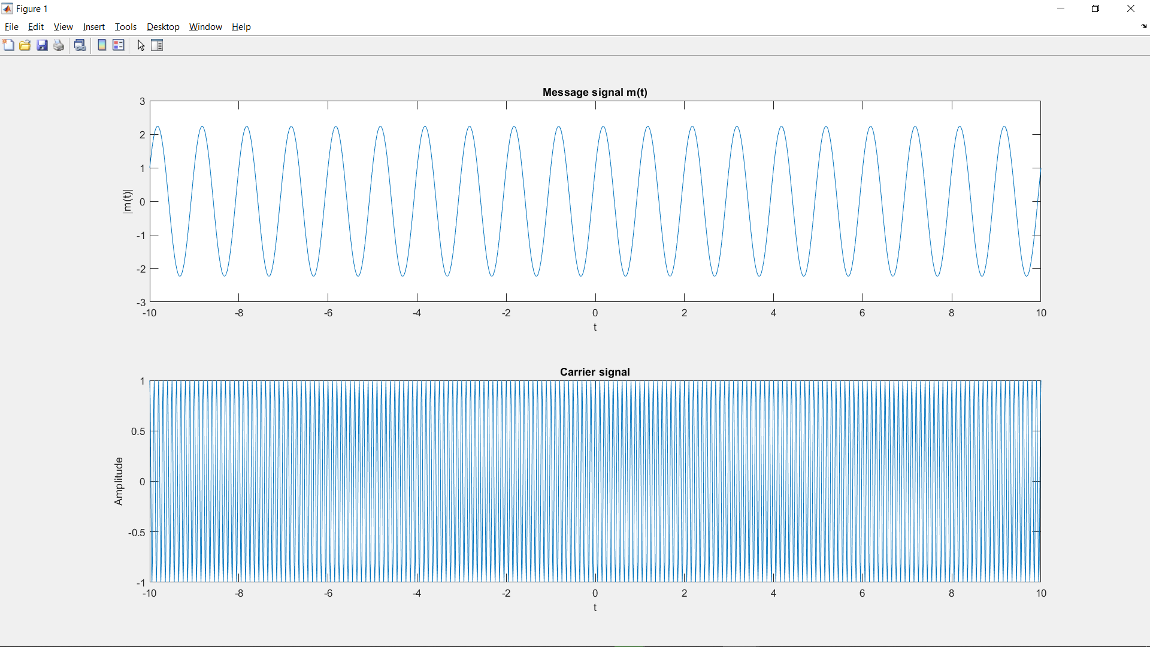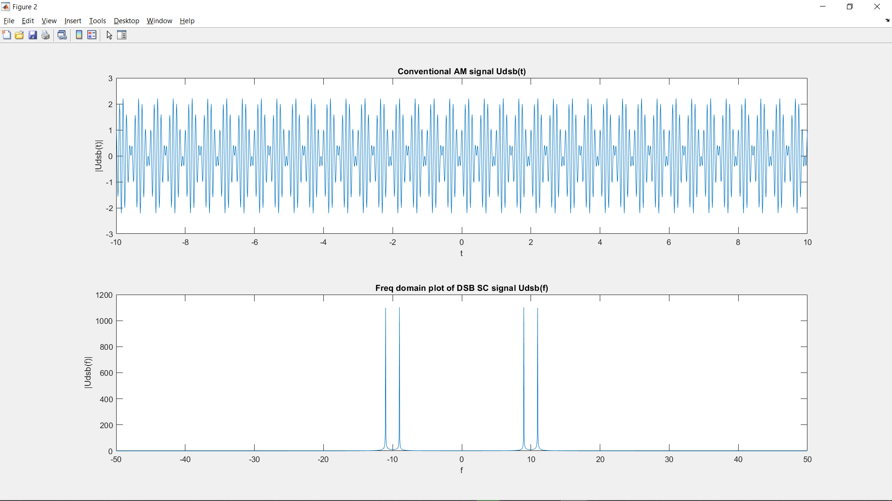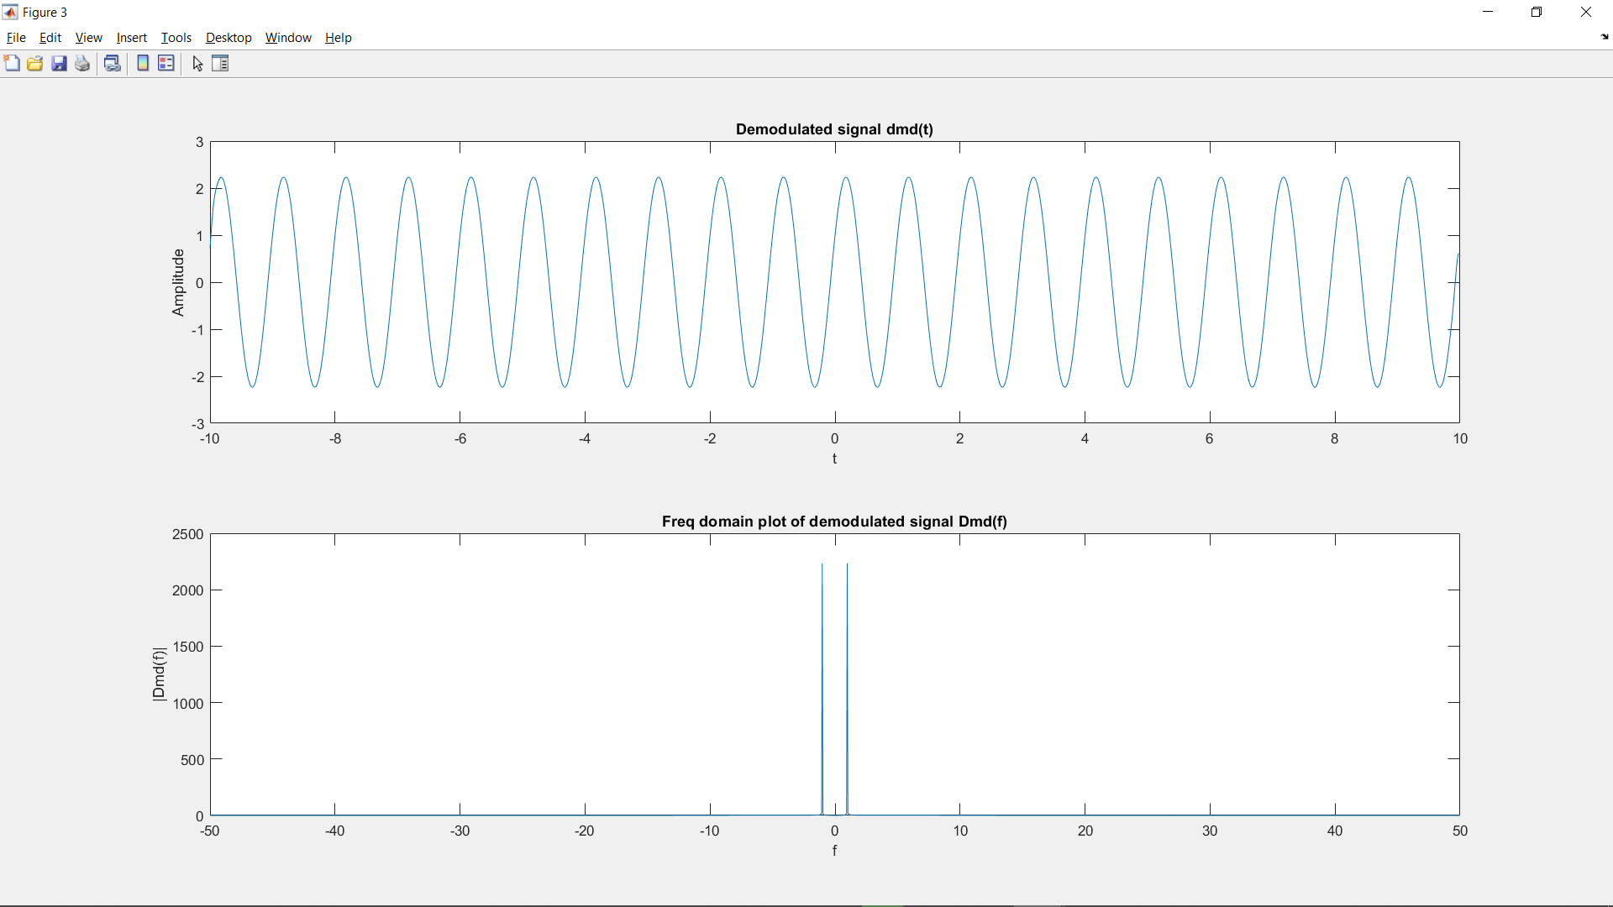

Inferences/Observations:

The freq domain plot of DSB SC signal has both USB and LSB component but no component at fc.

The demodulated signal is same as message signal.

——————————————————————————————————————————

**c. Single Sideband Suppressed Carrier (SSB SC) modulation technique**

*CODE:*

clear all

fs=100; %sampling freq

t=-10:1/fs:10; %declaring time array

m=2*sin(2*pi*t)+cos(2*pi*t); %message signal

mh=imag(hilbert(m)); %hilbert transform of m(t)

fc=10; %carrier freq

ussb=m.*cos(2*pi*fc*t)-mh.*sin(2*pi*fc*t); %DSB signal

%SSB SC signal in FREQ domain

Ussb1=fft(ussb); %FT of DSB SC sig (not centered around 0)

Ussb=fftshift(Ussb1);

n=length(Ussb);

f1=(-n/2:n/2-1)*fs/n; %freq array for DSB SC signal

%demodulated signal

dmd1=2*ussb.*cos(2*pi*fc*t);

dmd=lowpass(dmd1,fc/3,fs);

%demodulated signal in FREQ domain

Dmd1=fft(dmd); %FT of demodulated signal (not centered around 0)

Dmd=fftshift(Dmd1);

n=length(dmd);

f2=(-n/2:n/2-1)*fs/n; %freq array for demodulated signal

%SSB SC in freq domain

Ussb1=fft(ussb); %FT of AM sig (not centered around 0)

Ussb=fftshift(Ussb1);

n=length(ussb);

f=(-n/2:n/2-1)*fs/n; %freq array

%plotting message signal

figure(1);

subplot(2,1,1);

plot(t,m)

title("Message signal m(t)")

xlabel("t")

ylabel("|m(t)|")

%plotting carrier signal

figure(1);

subplot(2,1,2);

plot(t,cos(2*pi*fc*t))

title("Carrier signal")

xlabel("t")

ylabel("Amplitude")

%plotting SSB SC signal Ussb(t)

figure(2);

subplot(2,1,1);

plot(t,ussb)

title("SSB SC signal Ussb(t)")

xlabel("t")

ylabel("|Ussb(t)|")

%plotting freq domain SSB SC signal Ussb(f)

figure(2);

subplot(2,1,2);

plot(f,abs(Ussb))

title("SSB SC signal Ussb(f)")

xlabel("f")

ylabel("|Ussb(f)|")

%plotting Demodulated signal in time domain

figure(3);

subplot(2,1,1);

plot(t,dmd)

title("Demodulated signal dmd(t)")

xlabel("t")

ylabel("Amplitude")

%plotting freq domain plot of demodulated signal

figure(3);

subplot(2,1,2);

plot(f2,abs(Dmd))

title("Freq domain plot of demodulated signal Dmd(f)")

xlabel("f")

ylabel("|Dmd(f)|")

OUTPUT PLOT:

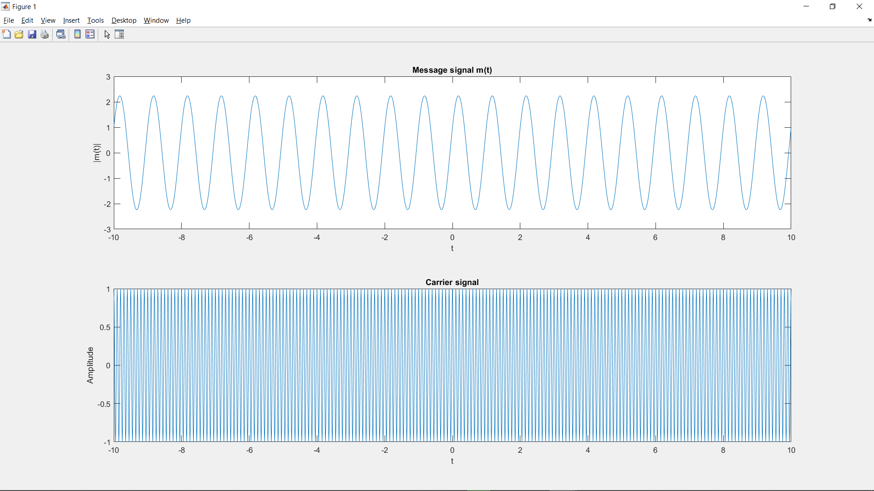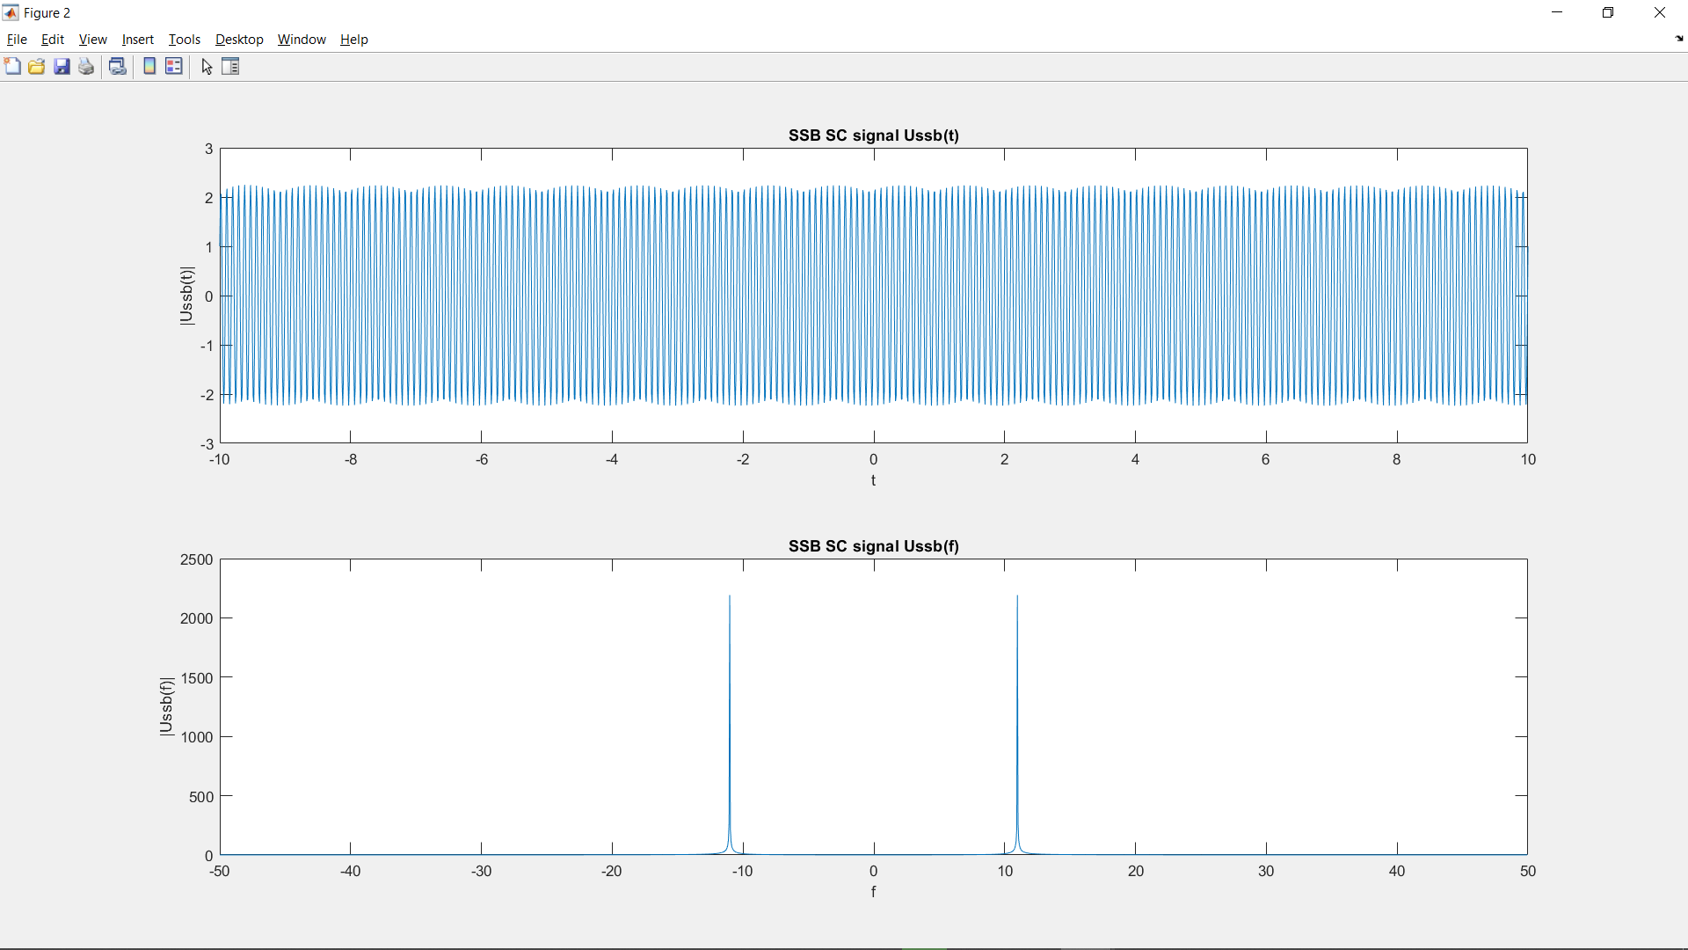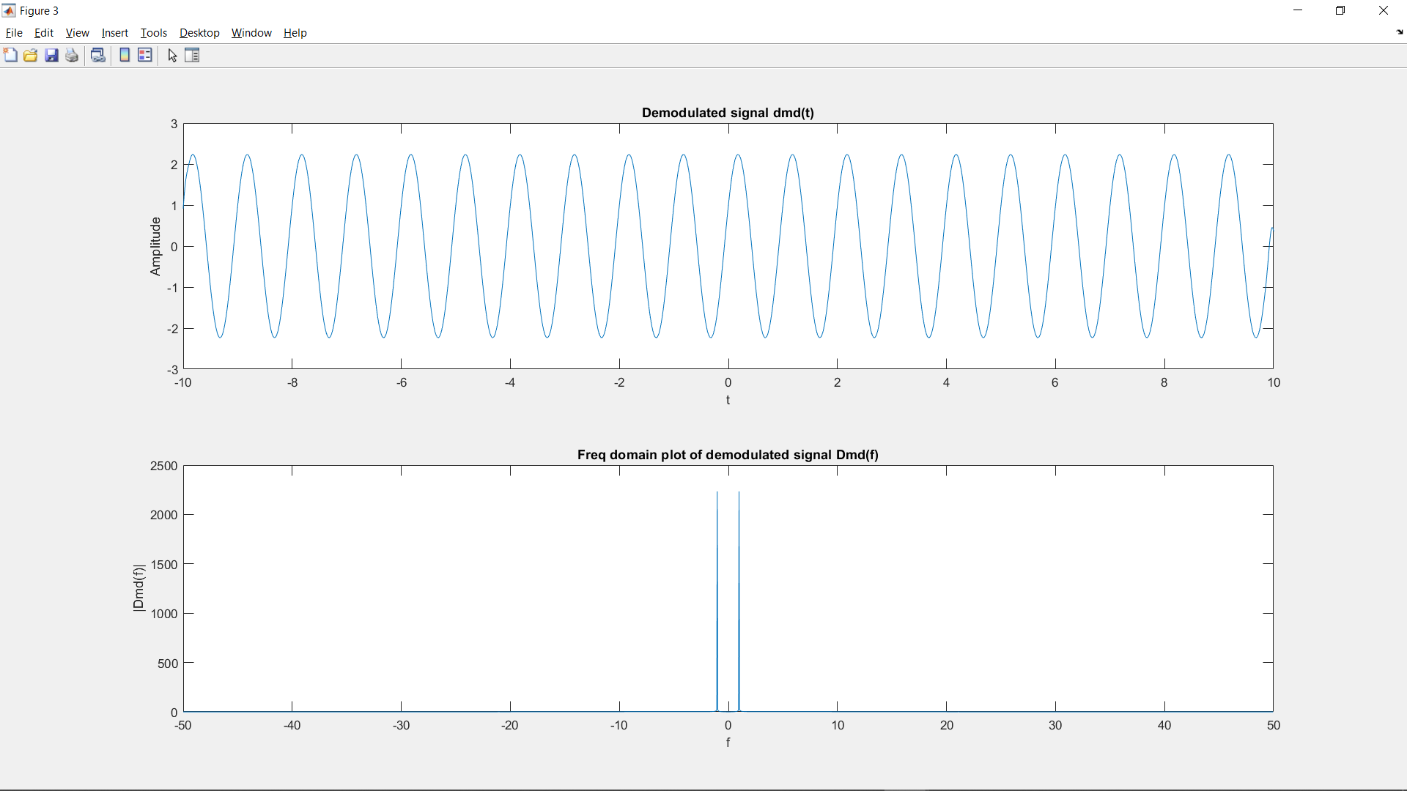

*Inferences/Observations:*

The freq domain plot of SSB SC signal has freq only in the USB and no component at fc.

The demodulated signal is same as message signal.